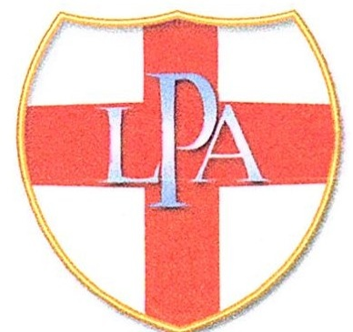

|  |
| --- |
| **LPA**  **Photographer of the Year Competition (POTY)**  **THREE ON A THEME**  2025 Entry Form  Sunday 23th November, 1.00pm for 1.30pm  Prints and entry forms must be with the organiser by Sunday 2rd November (Inter Club PDI Competition) at the latest.  Competition entry is free. There will be a door entry charge of £3 at the event for everyone. |

|  |  |
| --- | --- |
| Name: |  |
| Telephone number and email: |  |
| Club: |  |
|  |  |
| Monochrome Panel Title No 1: |  |
| No 2: |  |
| Colour Panel Title No 1: |  |
| No 2: |  |
|  |  |

|  |
| --- |
| **Organiser: Martyn Wrigg**  **Mounts should be full size (500mm by 400mm).**  **Please use backing board if possible and do not use masking or other peelable tape.**  **The organiser reserves the right to reject any unsuitably mounted prints and cannot be held responsible for any damage that may occur.** |