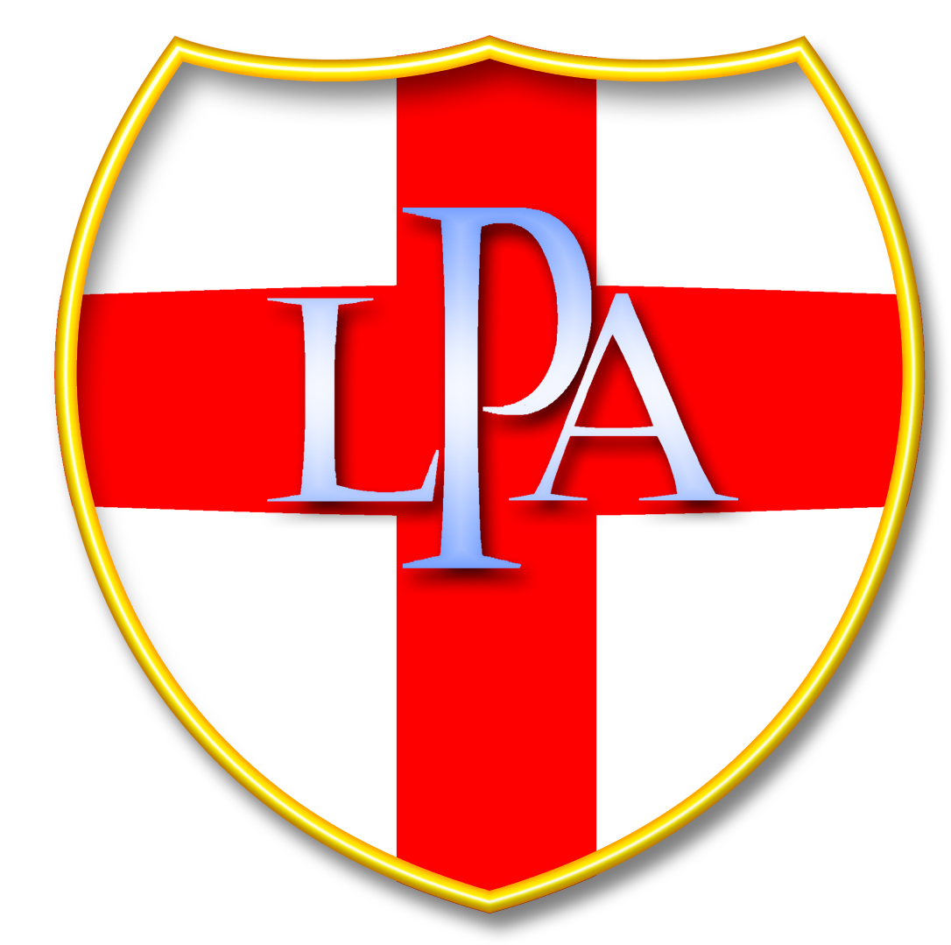 | LPA Inter-Club PDI  2024 Entry Form
Nettleham Village Hall: Sunday 2nd November 2025 (13:30 for 14:00 start)
Please return to the organiser by 19th October 2025
10 Digital Images. Maximum 2 per author.
Competition entry is free; there is a door entry charge of £3 at the event.
Images will be projected at a 16:9 ratio with maximum pixel sizes of:
1920 wide by 1080 high
Images must be titled as follows for them to be accepted by the software:
Title by Author.jpg
The order will be taken from the list below.
Please save this form to your computer, fill in your details, save the document, and email it to the organiser as an attachment.
Club Name:
Club Competition Secretary:
Club Contact Details:

Image Title
1.
2.
3.
4.
5.
6.
7.
8.
9.
Tie Break

None of the above images may have been previously entered in either the
Print Battles / Inter-club PDI Competitions previously.
Please return to the Inter-Club PDI Organiser – jorj.malinowski@gmail.com

LPA Clubs like to show the competition on a club night; therefore, entering this competition automatically allows the LPA to put the images on a DVD for club viewing.

